The inadequacy of our economic agenda
By Ishrat Husain
Published: January 25, 2011
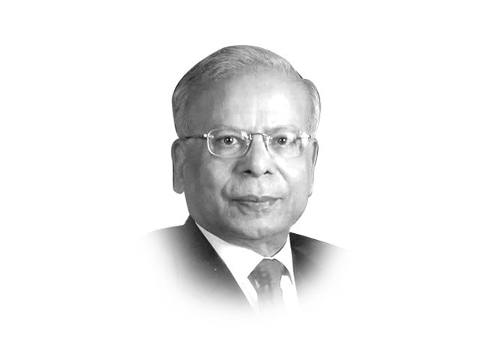
The writer is Dean and Director of IBA, Karachi, and a former governor of the State Bank of Pakistan ishrat.husain@tribune.com.pk
The government and opposition parties deserve the nation’s gratitude for sitting together to evolve a national consensus on finding solutions to the economic problems facing the country. My research suggests that the setting of long-term economic direction, continuity and consistency of economic policies, as well as the predictability and transparency of decision-making, are important factors that boost investor confidence and stimulate economic growth. Changes in political regimes, under those conditions, do not make any significant negative impact.
The present efforts by the federal government’s economic team to seriously discuss a 10-point economic agenda are highly commendable. But in my view, this agenda is highly inadequate to resolve the short-term crisis in public finances, or to restore investor confidence in the long-term. It has internal contradictions and has to be supplemented by other tough, politically unpopular measures. The success of the national consensus lies precisely in the fact that decisions which cannot be taken alone by the party in power, but which are essential for national welfare, become possible.
In the agenda, only a few points directly pertain to the economy and these are also problematic. The rollback of petroleum prices is a highly dangerous move because the post-2007 crisis was triggered largely by the inability of the then government to adjust the prices of petroleum products. Political parties may consider this a well-intentioned move to benefit the common man, but this argument is flawed. Iran, one of the leading exporters of oil in the world, has recently decided to increase the price of petroleum by 75 per cent, and that of diesel by 200 per cent. President Mahmoud Ahmedinejad — no friend of the IMF — has forcefully argued that subsidies on petroleum, electricity, gas, flour and cooking oil amounting to $100 billion will be phased out because these subsidies favour the rich. A country like Pakistan, which is already facing a fiscal deficit close to Rs1 trillion, can hardly afford to absorb these subsidies. With the revenues already spoken for and inadequate to meet the non-discretionary expenditures of debt servicing, defence and running of the civil administration, there is hardly any room for manoeuvre in the budget. There is a high risk that the external concessional resources in the budget may not flow in if donors withhold their funding, considering the rollback of petroleum prices an infringement of the agreement. In that event, the deficit may widen and borrowing from the State Bank may have to increase further. The inflationary consequences of the creation of this high-powered money for the economy are going to be disastrous. The Central Bank, in order to defuse inflationary expectations, would have to raise the policy interest rate, thereby nullifying any incipient attempts for the resurgence of private sector investment. The exchange rate may also be hit adversely, as the growing inflation differential between the US and Pakistan would put pressure on rupee parity. The second round effects of rising world prices of petroleum and other commodities in rupee terms would, in fact, put pressure on the ordinary citizen’s consumption basket, a result quite contrary to bringing prices down — one of the points included in the 10-point agenda. The poor, in whose names these subsidies are given, are hardly the main users of petroleum products. They should be given cash grants such as the Benazir Income Support Programme, Baitul Mal, or employment under the guaranteed employment schemes. Lifeline consumers of electricity should be given a subsidy. This would cost much less and would be targeted to those who deserve financial support.
The demand for a 30 per cent reduction in government expenditure immediately is not workable. In the new calculus of inter-governmental fiscal relationships, the responsibility for inflexible expenditures, i.e. debt servicing, defence and civil armed forces, rests with the federal government but with a much reduced share in the divisible pool of tax revenues. On the other hand, the provincial governments, despite gaining almost 52 per cent more revenues from the divisible pool compared to Financial Year 2010, have large discretionary expenditures which can be curtailed. But the richest province, Punjab, which has always had a surplus in its account with the State Bank, is running a deficit on its balances. Other provincial governments are equally reluctant to impose any cut on their expenditures. Under these circumstances, it is not obvious if a reduction of this magnitude can be achieved.
It is also not clear how, in a regime of a substantial gap between demand and supply of electricity and gas in the country, loadshedding can be abolished. The crux of the problem in the energy sector is the inability to resolve the circular debt problem and make all future transactions current. The leakages, pilferage, inefficiencies, non-billing and non-payments of dues have made a big mess of our energy sector finances. The agenda should, therefore, focus on governance of public utilities.
The agenda is completely silent on resource mobilisation efforts because these are politically difficult. It is precisely for this reason that all parties should agree on an action plan whereby the vast majority of those who are earning taxable income but are outside the tax net, can be brought in to pay their dues. If this can be agreed upon, tax collection can potentially reach Rs2,100 billion annually, rather than Rs1,400 billion. In addition, devolution of financial and administrative powers to district governments can generate additional resources that are exclusively utilised for local infrastructure and basic services. There is almost a universal tendency that the closer to people’s homes the public expenditure incurred is, the higher the propensity to pay taxes or user charges will be. But instead of ridding the local government system of its inherent weaknesses and strengthening resource mobilisation and delivery of basic services, the system is in a state of limbo.
Finally, the agenda should also have a clear road map on privatisation of public enterprises. Those of a strategic nature should be retained, but restructured and run by competent professional managers of high integrity, chosen on merit. But non-strategic enterprises should be sold sooner than later. The ambivalence on the issue of privatisation is a big source of concern and can be set at rest by a clear statement in the consensus agenda. The losses incurred by these public corporations, if averted, can reduce the fiscal deficit. The components of a medium-term agenda can be elaborated on separately.
Published in The Express Tribune, January 25th, 2011

